**DIGIRAIL-TICKET VERIFICATION AND SEAT ALLOCATION**

**A. Guru Prakash**

**16EUEE040**

Sri Krishna College of Engineering and Technology - Coimbatore

**B. Bala Murugan**

**16EUEE020**

Sri Krishna College of Engineering and Technology - Coimbatore

**ABSTRACT:**

Indian Railway is the world’s largest human transport system which is currently facing a lot of human related errors and problems. This paper tries to address the problems associated with manual system of ticket verification and seat allocation. This investigation presents an automated Biometric System for use in Indian Railway for ticket verification, which verifies passenger’s ticket through the biometric input (finger print). This minimizes the work of ticket collector in rail transportation. As in India, aadhar card is mandatory for all, it can be used as a tool for the project. The module installed in each compartment gets the passenger’s fingerprint and authentication is done using the information linked with aadhar id. Additionally, using GSM, information regarding berth confirmation will be immediately sent to the RAC (Reservation **against Cancellation)** passengers through SMS. By digitalizing the ticket verifying process, human errors can be highly reduced and verification process time can be minimized. And also RAC passengers don’t need to wait for TTE’s (Travelling Ticket Examiner) approval.

Keyword: Fingerprint, Biometric, GSM, Verification

**I.INTRODUCTION:**

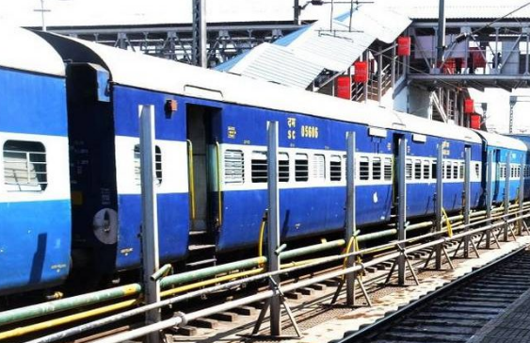

***Fig. I. Indian Railway***

**(i).BACKGROUND:**

**Before dwelling on the current project, a handsome knowledge about the prevailing system of railway booking is essential. Right from allotment of ticket with berth number to reservation against cancellation to the role of travelling ticket, this section deals conservatively. It will help to understand the problem faced by the Indian railway and the solution this project provides for the impediment.**

**(ii).INDICATON OF BERTH/SEAT NUMBERS :** Passengers with confirmed reservation will be allotted berths at the time of booking and the coach and berth numbers are indicated on the ticket itself, except in case of first class ACC and first class coaches. The compartment/cabin/coupe numbers for first ACC and first class are allotted at the time of chart preparation.  
  
**(iii).RESERVATION AGAINST CANCELLATION (R.A.C.) :** The passengers whose names figure under R.A.C., are provided reserved sitting accommodation initially and are likely to get berths becoming vacant due to last minutes cancellation of reservation of passengers not turning up in time before the departure of the train.  
  
**(iv).WHEN RESERVATION WORK CEASES:** The requests for reservation at the reservation counters are accepted up to 4 hours before the scheduled departure of the train, after which, the reservation will be done at the current counters at the stations up to one hour before the scheduled departure of the train and thereafter by the Ticket Collector/Conductor on the platform, if vacant berths/seats are available.  
 **(v).RESERVATION FROM INTERMEDIATE STATIONS:** Requisition for reservation of berths in all classes from intermediate stations not having computerized reservation facility is entertained on purchase of journey tickets only. Such requisition should be given to the Station Master of the Intermediate station 72 hours before the scheduled departure of the train from the station. Such application shall be sent to the nearest computerized reservation office at the earliest.  
  
**(vi).CANCELLATION OF RESERVATION DUE TO LATE ARRIVAL OF PASSENGER:** If a passenger, for whom a berth or seat has been reserved, does not turn up to 10 minutes before the scheduled departure of the train, the Railway Administration may cancel the accommodation reserved for him and allot it to the passenger on the RAC list/Waiting list accordingly on priority.

**II.TTE (Travelling Ticket Examiner) ROLE:**

* He shall report for duty at least one hour before the scheduled departure of the train at the train originating station and at least half an hour before the schedule arrival of the train at the intermediate station .He shall wear a neat and clean uniform along with number, Badge, Name Plate, etc .He shall sign On and Off Register maintained at the station.
* He shall check the tickets of the passengers in the coach and guide the passengers in occupying their accommodation. He prevents illegal/unauthorized entry in the coach including the platform ticket holders.
* He shall ensure that the number of passengers do not exceed the carrying capacity of the coach.

**III.HARDWARE DETAILS:**

**(i). FINGER PRINT SENSOR:**

The growth of biometrics system nowadays has been phenomenal around the world and its application ranges from safety to privacy and confidentiality. So there is made rush among the business organizations to grasp this technology to its fullest magnitude. This technology boasts of its salient features such as immune to fraud and eliminates security problems by identifying the unique person. Another advantage of biometric technologies is that they cannot be breached by fraudsters and cheaters as it is tightly bound to the individual. Using the fingerprint as security and identification process, fingerprint technology become foolproof system and it is becoming synonymous with biometric systems. Moreover Fingerprints are very distinctive and Fingerprint details are permanent even if they temporarily cuts or bruises on the skin. For criminal investigation, the department relies ultimately on Fingerprinting. Using a scanner, the inked impression of fingerprint can be captured can be captured instantly and quickly. The fingerprint contains detailed pixel information from the friction ridges and valleys of the image

.

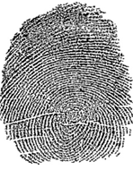

*Fig. III.1.Pixel image of human fingerprint*

R308 is a separate fingerprint reader, used high speed special DSP as core parts, compatible different fingerprint sensor. It is an intelligent module which can freely get fingerprint, image processing, verified fingerprint, search and storage, and it can work normally without upper monitor’s participatory management. Fingerprint processing includes two parts: fingerprint enrollment and fingerprint matching (the matching can be 1:1 or 1: N). Enrolling fingerprint, user needs to enter the finger 2-4 times for every one finger; process finger images with many times, store generate templates on module. When fingerprint matching, enroll and process verified fingerprint image And then matching with module (if match with appoint templates on the module, named fingerprint verification, For 1:1 matching method; if match with many templates on the module, named fingerprint search method also named 1:N) system will return the matching result, success or failure. 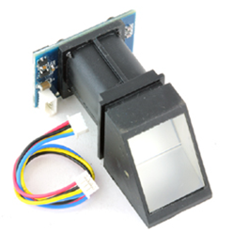

*Fig.III.2. Fingerprint sensor module*

**(ii). ARDUINO DEVELOPMENT BOARD:**

"**Arduino**" is a software development environment and any of several **microcontroller** boards that the software environment can develop programs for. Most of the boards use Atmel AVR **microcontrollers**. **Arduino** is a **microcontroller** based platform (ATMEGA 328 for the UNO). Arduino Uno is a microcontroller board based on the **ATmega328P**. It has 14 digital input/output pins (of which 6 can be used as PWM outputs), 6 analog inputs, a 16 MHz quartz crystal, a **USB** connection, a power jack, an **ICSP** header and a reset button. In fact, you already are; the Arduino language is merely a **set** of **C/C++** functions that can be called from your code. Your sketch undergoes minor changes (e.g. automatic generation of function prototypes) and then is passed directly to a **C/C++ compiler** (**avr**-g++).

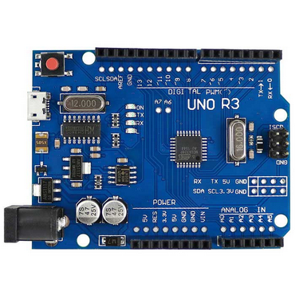

*Fig.III.3. Arduino UNO R3*

**(iii). GSM MODULE:**

**GSM**/GPRS **module** is used to establish communication between a computer and a **GSM**-GPRS system. Global System for Mobile communication (**GSM**) is an architecture used for mobile communication in most of the countries. Global Packet Radio Service (GPRS) is an extension of **GSM** that enables higher data transmission rate. The **SIM** card mounted GSM modem upon receiving digit command by **SMS** from any cell phone send that data to the MC through **serial** communication. While the program is executed, the GSM modem receives command 'STOP' to develop an output at the MC, the contact point of which are used to disable the ignition switch. 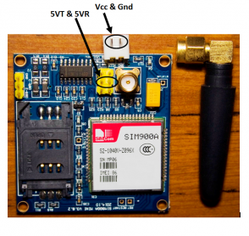

*Fig.III.4. GSM module*

GPRS **module** is a breakout board and minimum system of **SIM900** Quad-band/**SIM900A** Dual-band **GSM**/GPRS **module**. It can communicate with controllers via AT commands (**GSM** 07.07, 07.05 and SIMCOM enhanced AT Commands). This **module** supports software power on and reset

**(iv). LCD DISPLAY (16 x 2):**

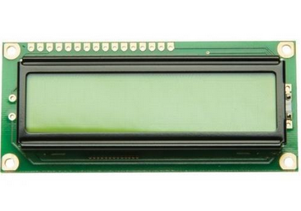 **LCD** (**Liquid Crystal Display**) **screen** is an electronic **display** module and find a wide range of applications. A **16x2 LCD display** is very basic module and is very commonly used in various devices and circuits. ... In this **LCD** each character is **displayed** in 5x7 pixel matrix. This **LCD** has two registers, namely, Command and Data. The command register stores the command instructions given to the LCD. A command is an instruction given to LCD to do a predefined task like initializing it, clearing its screen, setting the cursor position, controlling display etc. Processing the commands will happen in the command register. The data register stores the data to be displayed on the LCD. The data is the ASCII value of the character to be displayed on the LCD. When we send data to LCD it goes to the data register and is processed there.

*Fig.III.5. LCD Display*

**IV.BLOCK DIAGRAM:**

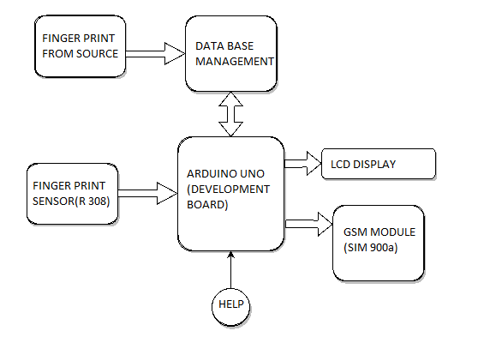

*Fig.IV.1. Block diagram of DIGIRAIL*

Reservation is done using aadhar or any proof linked with aadhar. Roping in UIDAI, a database of finger print of every person of India who is going to board the train is easy to develop. The finger print of the person booking ticket in Indian railway is taken from the server by using aadhar card number and a database of the particular train is created. Any cancellation of ticket should be done before 4 hours from the departure time.

A Finger print sensor module(R-308) is placed in every compartment of the train. The passenger should check in to the train by placing his finger in the module. If the finger print matches with the database of the particular train, the module will authorize him to claim his seat/berth. When the module fails to identify a reserved passenger due to technical or other problems, a “HELP” button pressed will send a message to the TTE for verifying the passenger reservation ticket manually.

LCD will display the authentication message as” verification successful ”, if the finger print matches with the UIDAI information else the LCD displays “ not verified ”then the user has to press help button so that he will be aided by the TTE’s HELP personally. The HELP button placed integral with every module will send message to the TTE about the hitches and the exact location of the help required (compartment number) using GSM module (SIM 900a).

Finally, if the passenger does not show up or forgets to keep the fingerprint for verification to claim his/her berth within 10 minutes after the departure of the train will be alerted through a SMS. After that 10 minutes, the GSM module will send a berth confirmation to the first RAC passenger (priority based).

**V. CONCLUSION:**

By employing this application in Indian Railway for ticket verification, the process time taken for ticket verifying and seat allocation will be reduced. And seat allocation for RAC (**Reservation Against Cancellation) is made faster than usual. This project aims at controlling fraudulence and improving transparency, errorless ticket verification and seat allocation process. As all the fields in world employing technology for the betterment of the people, this DIGIRAIL application will be a huge success for India because we have the world’s largest railway transport system. So the work of the TTE (Travelling Ticket Examiner) will be minimized on the whole and his role can be defined for the betterment of the railway.**

**VI. LIMITATION:**

The following are the limitations for the fingerprint technology enabled ticket verification and seat allocation system.

* 2nd or 3rd degree burns on the fingers may affect the sensors ability.
* Skin diseases like dermatitis, trauma, eczema, scleroderma also affects the ability.
* Senior citizen (sometime ageing affects finger prints of a person).

**VII. FUTURE ENHANCEMENT:**

**In future, this application can be further developed for highly accurate verification using optical sensor (eye scanner) with height adjustments and further more.** It is also possible to allot the berth to the nearest RAC passenger. Placing the Finger print, after the journey to minimize the misuse of other passenger’s ticket while travelling.